14/04/20
THM 121 Business Mathematics
Midterm Exam Answer Sheet
Note to the students:
- Calculations to reach your answers shall be thoroughly shown. Otherwise, questions will NOT be graded.
- You can use a calculator throughout the exam.
- Factor and simplify the given expression as much as possible: (2 Points)
[(-5χ – 6) / (χ² + 2χ – 3)] + [(χ + 2) / (χ – 1)]
[(-5χ – 6) / (χ² + 2χ – 3)] + [(χ + 2) / (χ – 1)] = [(-5χ – 6) / (χ – 1) (χ + 3)] + [(χ + 2) / (χ – 1)] = [(-5χ – 6) / (χ – 1) (χ + 3)] + [(χ + 2) (χ + 3) / (χ – 1) (χ + 3)] = [(-5χ – 6) + (χ + 2) (χ + 3)] / [(χ - 1) (χ + 3)] = [-5χ – 6 + χ² + 2χ + 3χ + 6] / [(χ - 1) (χ + 3)] = [χ²] / [(χ - 1) (χ + 3)].
- Factor and simplify the given rational expression: (2 Points)
[4 / (χ +3)] – [2 / (χ + 4)] – [(2χ + 3) / (χ² + 7χ + 12)]
[4 / (χ +3)] – [2 / (χ + 4)] – [(2χ + 3) / (χ² + 7χ + 12)] = [4 (χ + 4) / (χ +3) (χ + 4)] – [2 (χ + 3) / (χ + 4) (χ + 3)] - [(2χ + 3) / (χ + 3) (χ + 4)] = (4χ + 16 - 2χ – 6 - 2χ – 3) / [(χ + 3) (χ + 4)] = 7 / [(χ + 3) (χ + 4)].
- Factor the given polynomial using integer coefficients: (2 Points)
2χ³ - 8χ² - 10χ
2χ³ - 8χ² - 10χ = (χ) (2χ² - 8χ – 10) = (χ) (χ + 1) (2χ – 10) = (2χ) (χ + 1) (χ – 5).
- Solve the following quadratic equation by completing the square: (2 Points)
15χ² - 14χ + 3 = 0
15χ² - 14χ + 3 = 0 ↔ χ² – (14/15) χ + 3/15 = 0 ↔ χ² – (14/15) χ = -1/5 ↔ χ² – (14/15) χ + (14/30)² = -1/5 + (14/30)² ↔ (χ - (7/15))² = (-1/5) + (7/15)² ↔ (χ - (7/15))² = (-45/225) + (49/225) ↔ (χ - (7/15))² = 4/225 ↔ (χ - (7/15))² = (2/15)² ↔ either χ - (7/15) = (2/15) or χ - (7/15) = - (2/15) ↔ χ = 3/5 or χ = 1/3.
- Use the quadratic formula to solve the following equation: (2 Points)
4ϳ² + 12j + 9 = 0
4ϳ² + 12j + 9 = 0; ∆ = (12)² – 4 (4) (9) = 144 - 144 = 0 ↔ .Therefore, there is 1 solution for this quadratic equation (j = -12 / 8 ↔ j = -3/2).
- Solve the given system of equations: (3 Points)
5χ - 4y = 12 AND 2 χ - 3y = 2
5χ - 4y = 12 (i) AND 2 χ - 3y = 2 (ii)
(ii) → χ = (3y + 2) / 2.
Substituting the value of χ into equation (i), we get: 5/2 (3y + 2) – 4y = 12 ↔ (15/2)y – 4y + 5 = 12 ↔ (7/2)y = 7 ↔ y = 2. If y = 2 then χ = [(3 * 2) + 2) / 2 = 4.
- Evaluate the given sum: (2 Points)
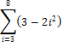
= (3 – 2*3²) + (3 – 2*4²) + (3 – 2*5²) + (3 – 2*6²) + (3 – 2*7²) + (3 – 2*8²) = (-15) + (-29) + (-47) + (-69) + (-95) + (-125) = - 380.
- Express the given sum in terms of summation notation: (2 Points)
(11/2) + 6 + (13/2) + 7 + (15/2) + 8 + (17/2)
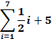
- Find the composite function: (2 Points)
ƒ (u-1) where ƒ (u) = (u+1)⁵ – 3u²
ƒ (u-1) = ((u - 1) + 1)⁵ – 3 (u - 1)² = u⁵ – 3(u² - 2u + 1) = u⁵ – 3u² + 6u – 3.
- It is estimated that t years from now, the population of a certain suburban community will be:
P (t) = 20 – [(6) / (t + 1)] (in thousand people)

- What will be the population of the community 9 years from now? (1 Point)
P (9) = 20 – [6 / (9 + 1)] = 20 – (6/10) = 20 – 0.60 = 19.40.
Therefore, the population of the community 9 years from now will be 19,400 people.
b) By how much will the population increase during the 9th year? (1 Point)
P (9) – P (8) = 19.40 – [20 – [6 / (8 + 1)]] = 19.40 – [20 – (6/9)] = 19.40 – 20 + (2/3) = - (6/10) + (2/3) = - (18/30) + (20 / 30) = 2/30 = 1/15.
Therefore the population will increase by 1,000 / 15 (i.e. 66.67 people) during the 9th year.
c) What happens to P (t) as t gets larger and larger? (1 Point)
As t gets larger and larger, the population P (t) gets towards 20,000 people.
- Suppose χ = -200p + 12000 units of a particular commodity are sold each month when the market price is p dollars per unit. The total monthly consumer expenditure E is the total amount of money spent by consumers during each month.
- Express the total monthly consumer expenditure E as a function of the unit price p. (1 Point)
E (p) = p * (-200p + 12000) = -200p² + 12000p.
- Sketch the graph of E (p). (3 Points)
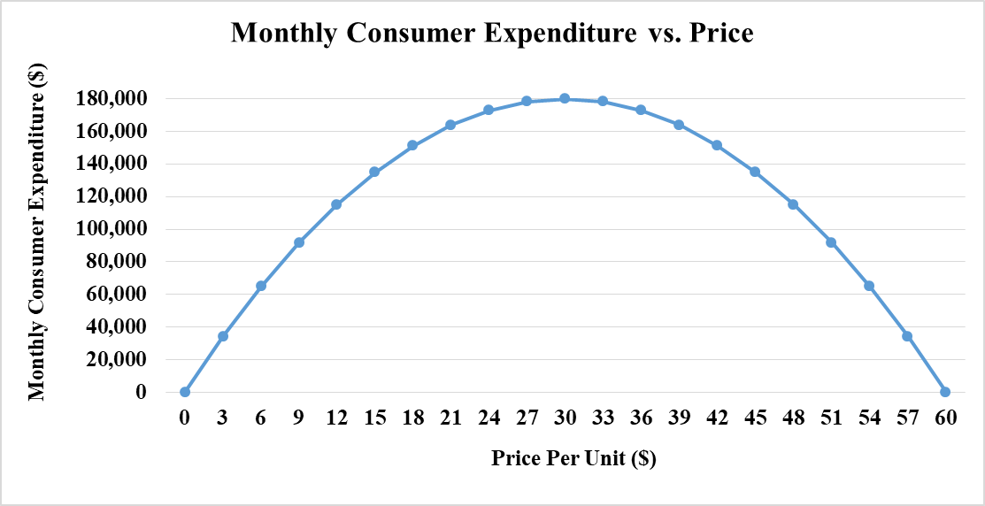
- Discuss the economic significance of the p intercepts of the expenditure function E (p). (2 Points)
The p intercepts represent prices at which consumers spend no money on the commodity.
- Use the graph plotted in part b) to determine the market price p that generates the greatest total monthly consumer expenditure. (1 Point)
Referring to the graph plotted in part b), the market price p that generates the greatest total monthly consumer expenditure is $ 30 per unit.
- A pay-as-you-go cell phone company offers a monthly plan for $ 19 that includes 200 minutes of calls. After that, calls are charged for 6 cents per minute up to a maximum of 500 minutes. Any call exceeding 500 minutes is charged at 4 cents per minute up to 1,000 minutes. Let C (m) be the cost in dollars of making m minutes of calls with a phone on this plan, for 0 ≤ m ≤ 1,000
- Write C (m) as a piecewise-defined function. (1 Point)
C (m) = 19 if 0 ≤ m ≤ 200
C (m) = 19 + 0.06 (m – 200) if 200 < m ≤ 500
C (m) = 37 + 0.04 (m – 500) if 500 < m ≤ 1000
- Sketch the graph of C (m). (3 Points)

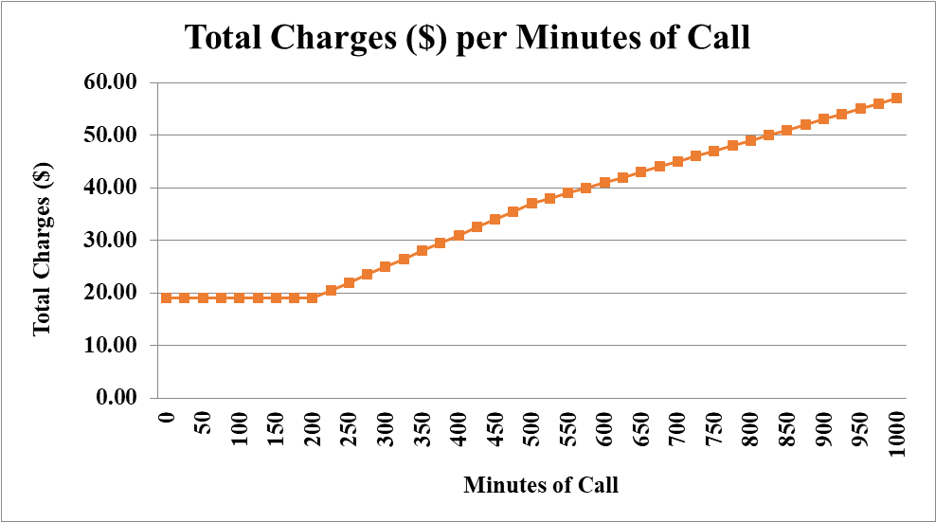

GOOD LUCK!

